Sew Compressor Teardown: A Few Basics
February 24, 2003

History Of The Screw Compressor
The early principle design of the screw compressor was first patented in Germany in 1878. In 1935, a compressor design using four male lobes and five female valleys was patented and is considered the birth of the modern screw compressor. The company making the patent changed its name in 1951 to SRM. Today SRM is known worldwide for its screw compressor and rotor knowledge and has issued manufacturing agreements to almost every screw compressor manufacturer that exists today.

What Is A Screw Compressor?
A screw compressor is a positive displacement volume reduction machine in which compression is achieved by the enmeshing of two helical grooved rotors positioned in a tight tolerance housing fitted with an inlet and outlet port.

Types Of Screw Compressors
Screw compressors can be either twin helical screws or a single screw design. They can be open drive, semi-hermetic, or hermetic in configuration. In addition, there are oil-flooded compressors and non-oil (dry) compressors. Screw compressors are designed to work in a wide variety of applications including, but not exclusively limited to, refrigeration, comfort cooling, open loop gas processes, and air compression.

How It Works
Compression occurs by the intermeshing of screws between tight tolerance housing bores. As the rotors turn in opposite directions, gas is drawn into the rotors through the inlet port and fills the compression pocket (thread) located between the male lobe and female rotor flute. The initial volume of gas is referred to as suction volume.
As the screws continue to rotate, the gas becomes trapped between the compressor housings and rotors and is moved axially and radially through the rotor housing. The compression cycle begins when the gas filled thread is closed off from the suction port. Additional intermeshing of the lobes results in the reduction (compression) of the initial suction volume of gas until the gas is released through the outlet port. Compression discharge is determined by the location of the outlet port.
To provide a better understanding of the compression process, the following illustrations compare the compression of gas in a reciprocating compressor to the compression of gas in a screw compressor.
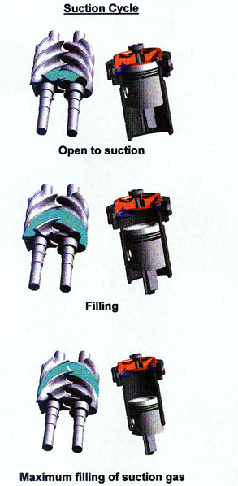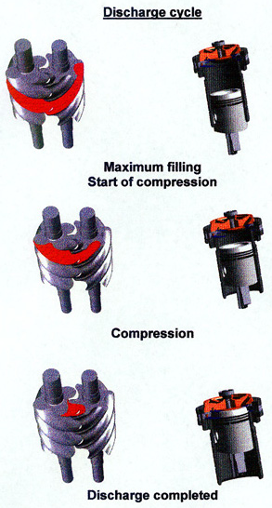
The illustration below represents a compressor with a slide valve and a moveable slide stop. There are two discharge ports, the radial port located on the slide valve and the axial port located in the discharge housing.
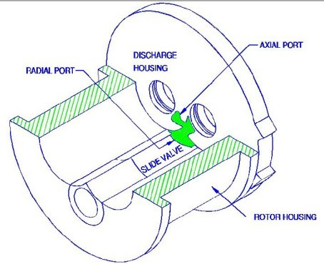

What’s On The Outside
Various ports are located throughout the exterior of the compressor. Standard ports such as oil supply to the shaft seal, balance piston, and main oil injection are used on nearly all oil-flooded compressors. Other ports are used for liquid refrigerant injection for oil cooling as well as a vapor return port (economizer) used to pull on a second evaporator. Electronic devices to monitor the position of the slide valve and slide stop, if available, are also affixed to the compressor.

What’s On The Inside
Unlike reciprocating compressors, screw compressors are fairly limited in the amount of internal components they contain. Major internal components would consist of the following.

Bearings:
As the gas is compressed along the length of the rotors, the rotors are forced in the radial and axial directions. To maintain rotor position, two types of bearings are used. Bearings are identified as ball thrust bearings and journal bearings.
Thrust bearings are required to control the axial (back and forth) movement of the rotors. Two designs that are typically used are the single angular contact and the four-point contact bearing. Single angular contact bearings are designed to take a load in only one direction; therefore two identical bearings are used and positioned back-to-back to control the axial force in both directions. The four-point contact bearing is designed to take the axial force in both directions. One four-point contact bearing takes the place of two single angular bearings.

Radial bearings are used to maintain the (up and down and sideways) movement of the rotors. Two of the most common bearings used today are the sleeve bearing design and the cylindrical roller design. Sleeve bearings utilize a sleeve placed in the compressor housing that runs against the rotor shaft. The design of the sleeve bearing requires the oil supplied to the bearing to be free of gas bubbles. Gas bubbles entering the bearing will collapse and allow the bearing to go metal-to-metal resulting in a bearing failure. To obtain a solid column of oil, a pump is used to raise the oil pressure over discharge pressure to eliminate the flashing of refrigerant in the oil supply. Typical oil pressure is approximately 25 psig higher than discharge pressure.
The roller bearing, also referred to as an anti-friction bearing, is a precision component consisting of cylindrical rollers, cage, inner ring/raceway, and outer ring/raceway. The cage is secured in the outer race and maintains the position of the rollers. The outer race is fitted snugly in the compressor housing whereas the inner race is secured to the rotor shaft by interference fit. As the shaft rotates and radial forces occur, the load is transmitted from the inner race, through the rollers and into the outer race. Lubrication is required to avoid metal-to-metal contact between components and to reduce excessive frictional heat.
Unlike the sleeve bearing that requires bubble-free oil between the two sleeves, roller bearings are not affected by gas bubbles in the oil. The anti-friction bearing rolls over the foam and collapses the gas bubbles out of the oil, leaving a solid oil supply to the oil reservoir in the bearing cavity. Because anti-friction bearings are effective with foamy oil, the need for a full-time pump to raise the oil pressure over discharge is eliminated. Oil is forced in the bearing cavities through differential pressure rather than by a pump. Many compressor units on the market today are sold with only pre-lube pumps or no oil pumps.
Balance piston:
As previously mentioned, thrust bearings are installed on each rotor to hold the rotor against axial forces. The higher the gas load force applied to the rotor, the greater the force that is applied to the thrust bearing. To help offset the axial load of the thrust bearing, a balance piston is installed on the rotor. The balance piston’s function is to extend the operational life of the thrust bearing.
Typically, a balance piston is of a two-part design consisting of a rotating piston and a stationary sleeve. The piston, designed with a labyrinth seal on the OD, fits snugly into the balance piston sleeve with a very small clearance between each component. High-pressure oil is supplied to the piston resulting in an opposing force on the rotors, eliminating some of the axial load applied to the thrust bearing. Again, depending upon the compressor manufacturer, balance pistons can be located on the male rotor, female rotor, or both.
Shaft Seals:
Because of the open drive design, a shaft seal is required to prevent oil and gas leakage from occurring around the drive shaft. This is also the component that draws the most attention. Shaft seals can be as simple as a standard carbon assembly and mating hard face metal seat, to elaborate designs such as tandem and compound seals. Typically, the refrigerant and the application of the system determine the type of seal used.
A high percentage of applications use the standard carbon seal mating with a hardened metal seat. The carbon can either be stationary (non-rotating) or attached to the rotor (rotating). Due to the shaft seal being flooded with oil, some oil leakage during operation is considered normal. A tandem seal is designed to prevent any type of leakage to the atmosphere.

Capacity Control
There are a number of capacity control methods used in screw compressors throughout the industry. A few are:
• Slide valve controlling discharge port;
• Slide valve controlling discharge port and volume ratio;
• Slide valve not controlling discharge port;
• Plug valves; and
• Variable speed drive.

Volume Ratio (Vi) Slide Stop
In reciprocating compressors, the discharge valve opens when the gas pressure in the cylinder bore exceeds the pressure upstream of the discharge valve. Screw compressors do not have discharge valves; therefore the location of the discharge port determines the maximum discharge pressure that can be obtained before the gas is released to the discharge piping.
What must be considered when applying a screw compressor in a system is the comparison of the internal volume ratio of the compressor to the volume ratio of the system. The comparison of the volume of trapped gas at suction (Vs) to the volume of trapped gas remaining in the thread pocket prior to release to discharge piping (Vd) is the internal Volume Ratio. The Vi or Volume Index determines the compressor’s pressure ratio.
Therefore: Vi = Vs/Vd.
The evaporator determines the suction pressure entering the compressor; the discharge port of the compressor determines the pressure that will be released. The discharge pressure may or may not match that of the system’s discharge pressure depending upon the location of the discharge port. If the internal volume ratio is too high for a given set of operating conditions, the gas will be trapped for a longer period of time and the pressure will rise above the system’s discharge pressure. This is referred to as over-compression and results in increased energy usage. A graph representing over-compression is shown in Figure 1.
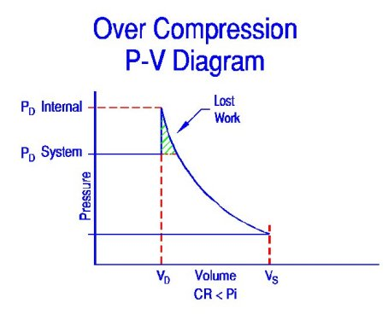
Figure 1. Diagram of over-compression.
The other end of the spectrum is when the internal volume ratio is lower than what is required for the operating conditions. This is referred to as under-compression. The gas is released at a lower pressure than what is in the discharge piping. The higher system pressure flows back into the rotors and increases the thread pressure to the higher pressure. The compressor now has to pump against the higher pressure. Just as in over-compressing, under-compressing results in excessive energy usage. A graph representing under-compression is shown in Figure 2.
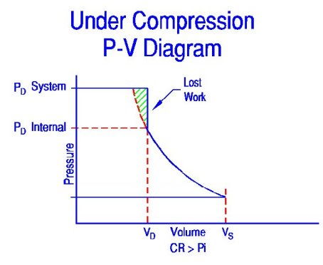
Figure 2. Diagram of under-compression.
It is ideal when the internal volume ratio matches the system’s volume ratio. A diagram representing ideal compression is shown in Figure 3.
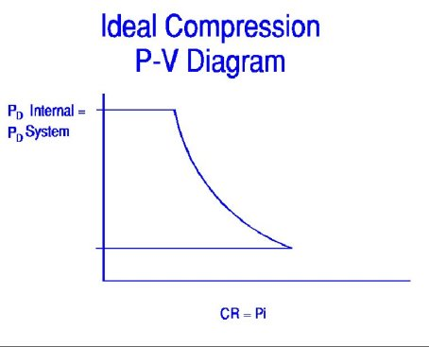
Figure 3. Diagram of an ideal compression ratio. The internal pressure matches the system’s condensing pressure.

Fixed Vi
Fixed volume ratio compressors are designed to operate in a specific range of operating conditions. Because the Vi is fixed, maximum efficiency is achieved when the compressor operates within the design parameters. Once the compressor operates outside the design parameters, the efficiency drops due to over-compression and under-compression of the gas. Some compressors used for particular applications in which the system’s conditions are fairly consistent use the fixed Vi design. Examples would be booster applications and comfort air chillers.

Variable Vi
Some of the most efficient compressors used in the industry are those that are equipped with a variable Vi. These compressors have both a movable slide stop and a movable slide valve. Capacity of the compressor is controlled with the slide valve as discussed in the capacity control section, whereas the internal volume is determined by the slide stop. Discharge and suction pressures determine the position of the slide stop. The variable slide stop is designed to travel in conjunction with the slide valve. As the slide stop moves, and with the slide valve at the 100% position, the discharge port on the slide valve is relocated. Relocating the discharge port changes the internal volume of the rotor thread, preventing the compressor from under-compressing or over-compressing the refrigerant gas.
The moving of the slide stop can either be performed manually or automatically. To control the slide stop manually, an operator determines the Vi position by using a chart outlining the calculations. The operator then moves the slide stop by opening and closing valves. In a manually controlled system, the Vi is typically limited to several different positions. To move the slide stop automatically, a computer or microprocessor is programmed to constantly calculate the slide stop position by monitoring the suction and discharge pressures. Once a change is needed, the processor calculates the desired location and moves the slide stop by the use of hydraulic pressure. The variable slide stop is designed to typically travel from a 2.2 Vi position to a 5.0 Vi position.
Figure 4 shows how a variable Vi compressor can relocate the radial discharge port on the slide valve to avoid under- and over-compression of the gas.
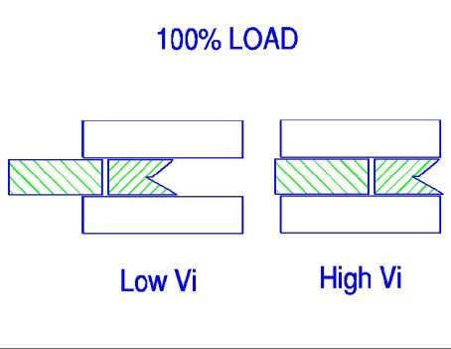
Figure 4. Diagram showing how a variable Vi compressor avoids under- and over-compression.

Maintenance
To ensure a full operating life from a compressor, preventive maintenance is absolutely essential. Because the compressor is mounted on a unit, operating conditions of the unit play a major role in the life of the compressor. Below is a list of preventive maintenance items dealing both with the compressor and the unit. First and foremost, always follow the manufacturer’s recommended maintenance schedule. However, the following recommendations can be applied to most systems.

Operating Logs
Recording the operating conditions every four hours or at least once per shift permits those responsible for the maintenance and servicing of the equipment to be constantly familiar with the operation of the system. Any deviation from the normal operating conditions is easily recognized and immediate steps can be made to correct the problem. A few typical areas to look for would be high or low discharge temperature, high or low oil temperature, low oil pressure, and high full load amp percentage.

Discharge Temperature
Lower than normal discharge temperatures could indicate liquid refrigerant carry-over or excessive liquid injection feed.
Higher than normal discharge temperatures could indicate an incorrect Vi (volume ratio) position, insufficient main oil supply, excessive suction line superheat, or an increase in the rotor end clearance.

Oil Temperature
Excessively high oil temperature can adversely affect the oil’s ability to supply proper lubrication.
If the oil temperature is too low, refrigerant may become entrained in the oil supply and enter into the bearing cavities.
An increase in full load amps while maintaining the same operating conditions could indicate a faulty bearing.

Rotor Thrust Measurement
Measuring the axial movement of the rotor can help determine the condition of the thrust bearing. By moving the rotor axially back and forth, and comparing that measurement with the “as built” measurement, excessive thrust bearing movement can be detected. Obviously, the drive rotor is easy to measure as it protrudes from the compressor; however, access to the non-drive rotor will require some disassembly of the compressor.
For compressors with anti-friction roller bearings for radial loads, clearance measurements can only be taken with a feeler gauge between the inner race and the top roller element. Do not pry the rotor up and down. Excessive radial movement of the rotor shaft could result in damage to the bearings.

Oil Analysis
The use of the correct oil in a compressor is essential for long-term operation. Ensuring that the oil quality is in line with the manufacturer’s recommendations is equally important. Conducting oil analyses in scheduled intervals allows the operator to know the condition of the oil and when it is time to change the oil. An oil analysis should look for viscosity, moisture, wear metals, particle count, and on certain refrigerants, total acid number. Consult the compressor manufacturer for testing lab recommendations. It is important to have a testing laboratory that is knowledgeable about refrigeration oils.

Vibration Analysis
Vibration analysis is a highly accurate and effective method to monitor the condition of anti-friction bearings. A quality vibration program, monitoring compressors with anti-friction bearings, can give advance warning of bearing defects long before a complete failure. Vibration analysis can also eliminate the need for periodic teardown inspections that are typically based on hours. It is important that the person taking the readings is familiar with the bearings and the operation of the compressor.

Being Familiar With The Compressor
Not all companies can financially afford the benefits of oil or vibration analysis programs. In this case, a trained operator can become familiar with their compressor to the point that changes in sound levels and pitches can alert them to a problem.
Remember that preventive maintenance is proactive and can save both time and money.

Servicing
Minor repair: This is usually defined as work performed on the compressor while it’s still mounted on the unit. Typical minor repair items would consist of replacing the slide valve and slide stop potentiometers, slide valve piston seal ring, and miscellaneous O-rings. High on the list of minor repairs would be replacing the shaft seal. Compressor manufacturers attempt to install reliable and durable shaft seals; however, the most durable shaft seal will have to be replaced eventually. A shaft seal, like bearings, is designed with a particular compressor and application in mind. It is important to consult the compressor manufacturer for the correct shaft seal.
Major repair categories: Major repair to compressors can usually be broken down into three categories. The first would be replacing bearings, O-rings, and fasteners. This type of repair is often associated with hours of operation rather than a known problem. Some manufacturers recommend this type of repair as a scheduled maintenance item. However, since the onset of vibration analysis, many end users now rely on vibration measurements to predict the need for rebuilding rather then operating hours. As discussed earlier, vibration analysis can often detect a problem before it is audible to the human ear.
The second category would be bearings, O-rings, and a few internal components. Again, this could be based on hours of operation and vibration readings as well as audible noise or compressor performance. Replaceable items could be balance pistons, slide valve, and slide stop.
The third category would include the first two groups as well as additional major components. Items such as rotors and major housings would be required as a result of a compressor failure. Compressors falling into this category will need to be evaluated to determine if rebuilding is a more financially advantageous decision than purchasing a replacement compressor.

Dismantling
Discussion on compressor dismantling is somewhat difficult due to the scores of different compressor designs on the market. No matter which design is being dismantled, a few basic steps and procedures should be followed.
• Have the right work area. Dismantling and rebuilding should be conducted in a clean environment free of airborne particles. Due to the weights of rotors and housings, an overhead lifting device is required.
• Use the proper tools. Because screw compressors have close tolerance clearances and precision components, most compressors require special tools designed by the manufacturer to remove and install bearings, locknuts, springs, etc. The use of these tools is critical to ensure that components are installed in a quality manner. The tools also allow the technician to work safely.
• Know what is inside the compressor. Some compressors have high-pressure springs as part of their design. Unknowingly removing a cover could launch the cover and the spring causing injury to the technician.
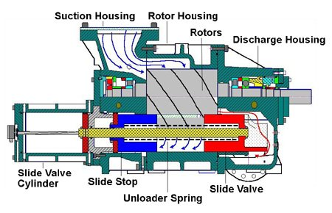
Be sure you know what is inside the compressor.

Assembly
• Conduct a full rebuild. A common mistake in compressor rebuilding is conducting a partial rebuild. A partial rebuild would consist of replacing only one or two of the bearings rather than all the bearings, or not replacing all the seal rings in the slide valve assembly. Although units have oil filters to protect the compressor, the oil porting in the compressor allows the oil to flow from one bearing to another. If the upstream bearing is worn, the downstream bearing will become contaminated.
• Use factory approved parts. Because of the critical design specifications and the particular application the compressor is used for, manufacturers use specific parts for specific compressors. For instance, o-ring material depends upon the refrigerant being used. The use of incorrect o-rings could result in the o-ring becoming hard, swollen, soft, or other types of deformities. The end result will be gas and oil leakage, and possibly excessive difficulty in dismantling.
Other critical items are bearings. Bearings are designed to handle specific loads, speeds, and conditions. Although the bearing manufacturer has a generic identification on their bearings, the identification may not always specify the exact bearing design. An example of this may be that the bearing clearance is not specified on the bearing code. As mentioned previously, it is strongly recommended to use the manufacturer’s designed shaft seal.
Once the correct seal is obtained, a few basic pre-installation techniques are recommended.
1. Ensure all compressor components are cleaned and ready for re-installation before removing the shaft seal from its package.
2. Once the seal is removed from the package, care must be taken to avoid contamination.
3. Never attempt to wipe the seal faces with anything other than a clean alcohol swab. Seal faces are lapped to two to three helium light bands. One helium light band is 11.6 millionths of an inch. Rubbing the faces with some other cloth may result in scratching the face.
4. The majority of shaft seals require coating the surfaces with oil prior to installation. Never wipe on the oil with a cloth or brush as both may either scratch the carbon or leave contaminants. The seal can be lubricated by either dipping the seal in clean refrigeration oil or by using a spray bottle.
5. Never use grease or products such as STP for either installation or lubrication. These products have a higher viscosity than refrigeration oil and may cause premature failure due to sludge formation.
Most shaft seals have an allowable oil leak rate; check with the manufacturer for the maximum allowable rate. Below is a list of possible causes for excessive shaft seal leakage.
• Misalignment between the compressor and motor.
• Improper or inadequate oil.
• Poor oil filtration.
• Incorrect shaft seal for the application.
• Incorrect o-ring material.
• Damage to an o-ring.
• Excessive axial and/or radial movement of the shaft.
• Improper installation.

Failure Analysis
Another important aspect in compressor rebuilding is to determine the cause of failure by analyzing the failed components. The most common mistake during a teardown evaluation is concentrating on the damage that occurred rather than what caused the damage. To get a better understanding of what to look for, the following is a list of possible failure modes.
• Inadequate lubrication:
Perhaps the leading cause for compressor failures can be attributed to lubrication-related problems. Poor lubrication will cause the bearings to fail. Although it could be described as a bearing failure, it would actually be a lubrication failure. Partial lists of items that contribute to a lubrication failure are listed below:
1. Using the wrong type of oil.
2. Contaminants such as moisture, particles, or liquid refrigerant.
3. Mixing different types of oils.
• Bearing failure:
Again, it has to be determined what caused the bearing to fail in order to determine what caused the compressor to fail. To determine a bearing failure, it is best to evaluate all the bearings. A partial list of bearing failure modes is shown below.
1. Failure due to defective bearing seats on shaft and in housings: For the bearing to achieve its life expectancy, it’s essential that the shaft and the housing be geometrically true with the bearing.
2. Misalignment: Misalignment can occur between the compressor and motor or it can occur if the inner ring is seated against a shaft shoulder that is not square.
3. Faulty mounting practice: Failures under this item occur from abuse or neglect of the bearing before and during mounting. Besides mechanical damage as a result of abuse, allowing the bearing to become contaminated will result in a premature failure.
4. Damage due to improper fit: This occurs when the wrong bearing design is used. This typically occurs when deviating from the manufacturer’s specified bearing.
5. Inadequate or unsuitable lubrication: This occurs when using the wrong specification of oil or poor quality oil.
6. Vibration: A unit that is vibrating excessively during operation will result in premature bearing failures. Another type of vibration-related failure is called false brinelling. False brinelling occurs when the compressor is off for an extended period of time without the rotor shafts being rotated while a nearby machine is running. Micro-motion occurs between the rolling elements and inner raceway that will eventually cause the raceway to fatigue at the contact point.
7. Passage of electric current through the bearing: In certain electrical machining applications, there is the possibility that an electrical current will pass through the bearing. A few possible causes would be stray magnetic fields or through a welding operation on some part of the machinery with the ground attached so that the circuit is required to pass through the bearings.
8. Old age: Bearings are chosen during the initial design of a compressor based on “L10” life. L10 life is defined as the operating hours that 90 percent of a bearing population would be expected to meet or exceed before any wear surface develops a 1 mm square fatigue spall. The median life is approximately five times the L10 life. Good quality lubricant and a clean operating system can give operating service life well beyond the calculated L10 life. However, if compressors run long enough, the bearings would eventually be expected to fail from fatigue, or old age.

Bearing Installation And Mounting
To ensure that the correct bearings are being installed, it is recommended that bearings be obtained from the compressor manufacturer.
Anti-friction bearings typically come in two mounting types, loose fit and interference fit. Loose fit bearings are designed to slide into the bore or over the shaft without resistance. Interference fit bearings require some assistance for installation.
Four different mounting methods are used for anti-friction bearings, including cold mounting, hot mounting, oil injection, and slip fit. The most commonly used methods are cold mounting, hot mounting, and slip fit.
Cold mounting takes place when a bearing is frozen prior to installation. Freezing shrinks the bearing allowing it to be easily installed in the bore. Once the temperature of the bearing increases, it fits snugly in the bore. Cold mounting is also used to describe a bearing that is mechanically forced into position. Hot mounting is used for bearings that require interference fit. A typical application would involve the inner race of an anti-friction roller bearing. Heating expands the race allowing it to be easily slid into position. As the race cools it adheres to the rotor shaft. Slip fit bearings simply slide into place with normal hand force.
Yoder is a service technician with York Refrigeration/Frick in Waynesboro, Pa. For more information, visit www.yorkref.com.
Publication date: 03/10/2003

As electricity is applied to the male rotor it begins to go out of mesh with the woman rotor producing a void permitting fuel to be drawn in via the inlet port. As the rotor maintains previous the inlet port the intermesh place carries on to grow until finally the fuel completely fills the interlobe room. When the male rotor enters the interlobe place it commences to convey and compress the gas in direction of the discharge port. As the rotors switch the gasoline stuffed grooves are isolated by the housing walls, making a compression chamber, the place lubricant is then injected to provide cooling, sealing and lubrication.
Continued rotation causes the gasoline quantity to lessen to the stated style force. The compressed gasoline and lubricant is lastly despatched via the discharge port, then into a two phase separator where the oil and gas are divided. The oil is filtered by a 10 micron automotive kind spin on filter and then cooled through air or h2o before getting re-injected into the compression chamber. The oil variety utilised in these machines is a hydrocarbon synthetic of ISO 100, 150 or 220 viscosities and is chosen dependent on particular gravity of the gas. Proper gasoline analysis is critical in oil choice as throughout initial begin up, fuel will dilute the viscosity of the oil. In the circumstance of an air compressor the gas is then directed to an air cooled following-cooler in which up to 70% of the ingested water vapor is condensed out of the gasoline stream before coming into the supply manifold.
The compression porting is positioned and cut to attain the application stress ratio. To achieve the biggest efficiency, it's central the corresponding geometry match the software strain demands. Some rotary screw compressor designs use a variable discharge valve that continually seek out highest efficiency by opening and closing depending on program strain circumstances. When the compressor senses a reduced technique air demand from customers (growing stress) the discharge valve enables air to circulate back to the inlet with out being compressed to meet method desire. The net effect is a shorter size rotor resulting in variable displacement operation allowing electrical power requirements to fall.
The displacement of the screw compressor is a operate of the interlobe volume and speed. The interlobe quantity is a perform of rotor profile, length and diameter. The interlobe volume can be expressed by the equation
Qr = d3 (L/d) / C
In which: Qr = Displacement/Revolution d = rotor diameter C = common profile continuous
Qd = Qr x N
Where: Qd = discharge volume N = compressor pace Qi = Qd x Ev
The place Qi = actual inlet quantity Ev = volumetric performance
Volumetric Effectiveness is a purpose of rotor slip which is the inner leakage developed by gasoline expansion back to the minimal stress facet as a result minimizing the likely quantity capacity of the compressor.
The screw compressor discharge temperature can be evaluated assuming adiabatic compression, assumes no power (heat) is transferred to or from the fuel for the duration of the compression and all supplied function is added to the inside strength of the gasoline ensuing in increase of temperature and stress.
Discharge temperature can be calculated by taking the adiabatic temperature increase and dividing by the adiabatic effectiveness, and then multiplying by the temperature increase effectiveness to account for cooling. To locate the last discharge temperature, add the inlet temperature to the temperature rise.

